Predicting NFL Draft Surplus Value via Gated Neural Networks STAT 421 NFL Combine Project Midpoint Showcase
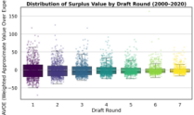A) Round vs. wAVOE 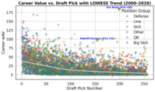B) wAV vs. Pick 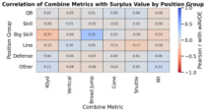C) Combine Correlations 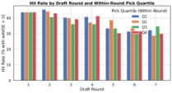D) Hit Rates
A) Later rounds exhibit much wider wAVOE spread, with occasional extreme surplus-value hits alongside many misses. B) Career wAV declines sharply with pick number, but the LOWESS curve highlights persistent pockets of outliers far above expectation. C) Combine wAVOE correlations differ by position group, with lower times in speed/agility drills generally aligning with higher surplus value where those skills are most position-relevant. D) Within-round hit rates vary meaningfully by pick quartile, suggesting that surplus value is concentrated in specific parts of the board rather than uniformly spread across each round.

